Data Visualization Project 

made by

**GROUP - A**

**ERAM PERWEZ PUSHPA KUMARI SUDHA KUMARI DAS PARAMITA DEWAN** 

**National Skill** 

**Training**

**Institute for**

**Women**

CP-16, CP Block, 

Sector V, Salt Lake

City, Kolkata, West

Bengal

**ACKNOWLEDGEMENT**

We are really grateful because we managed to complete our data visualization project within the given time by our teacher Mr.Abhishek Raman.

This project couldn’t be completed without the effort and cooperation of our group members.

We also thank our teacher Mr. Abhishek Raman for the guidance and encouragement in finishing this project and also for teaching us this course.

We would also like to extend our gratitude to our sir Mr. Sarbojit Neogi and our principal sir Shri G.C.Ramamurthy for providing us with all the facilities that were required.

DATE: 27/01/2021 Eram Perwez Pushpa Kumari

Sudha Kumari Das

Paramita Dewan

**TABLE OF CONTENTS**

**Sl. no. TOPICS Page no.**

**1 Introduction** 5 ➢ The Part of Power BI 5

➢ How Power BI matches our role 6

➢ Download Power BI Desktop 6

➢ Uses of Power BI 7

➢ Building blocks of Power BI 8

**2 Visualizations** 9 **3 Datasets** 10 **4 Reports** 11 ➢ Connect to data sources 11

➢ Connect to data 12

➢ Choose data to import 12

➢ Create reports 14

**5 Create and customize simple visualizations** 16 ➢ Modify colors in charts and visuals 16

➢ Create Pie Chart 18

➢ Create Stacked Column Chart 19

➢ Create Donut Chart 20

➢ Create Treemap Chart 21

➢ Create Stacked Area Chart 22

➢ Create a Table 23

➢ Create Funnel Chart 24

➢ Create Waterfall Chart 25

**6 Challenges** 26 **7 Conclusion** 26 **8 Bibliography** 26

**Introduction**

**Microsoft Power BI** is a collection of software services, apps, and connectors that work together to turn your unrelated sources of data into coherent, visually immersive, and interactive insights. Whether your data is a simple Microsoft Excel workbook, or a collection of cloud-based and on-premises hybrid data warehouses, **Power BI** lets you easily connect to your data sources, visualize (or discover) what's important, and share that with anyone or everyone you want.

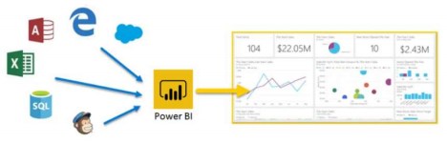

**Power BI** can be simple and fast, capable of creating quick insights from an Excel workbook or a local database. But **Power BI** is also robust and enterprise-grade, ready not only for extensive modeling and real-time analytics, but also for custom development. Therefore, it can be your personal report and visualization tool, but can also serve as the analytics and decision engine behind group projects, divisions, or entire corporations.

**The Part of Power BI**

Power BI consists of a Microsoft Windows desktop application called **Power BI Desktop**, an online SaaS (*Software as a Service*) service called the **Power BI service**, and mobile Power BI **apps** that are available on any device, with native mobile BI apps for Windows, IOS, and Android.

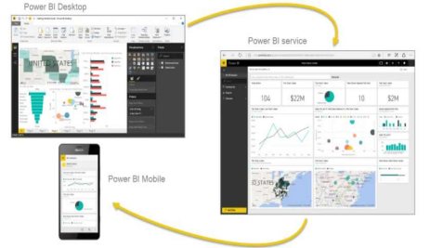

These three elements—**Desktop**, the **service**, and **Mobile** apps—are designed to let people create, share, and consume business insights in the way that serves them, or their role, most effectively.

**How Power BI matches our role**

How you use Power BI might depend on your role on a project or a team. And other people, in other roles, might use Power BI differently, which is just fine.

For example, you might view reports and dashboards in the **Power BI service**, and that might be all you do with Power BI. But your number-crunching, business-report-creating coworker might make extensive use of **Power BI Desktop** (and publish Power BI Desktop reports to the Power BI service, which you then use to view them). And another coworker, in sales, might mainly use her Power BI phone app to monitor progress on her sales quotas and drill into new sales lead details.

You also might use each element of **Power BI** at different times, depending on what you're trying to achieve, or what your role is for a given project or effort.

Perhaps you view inventory and manufacturing progress in a real-time dashboard in the service, and also use **Power BI Desktop** to create reports for your own team about customer engagement statistics. How you use Power BI can depend on which feature or service of Power BI is the best tool for your situation. But each part of Power BI is available to you, which is why it's so flexible and compelling.

We discuss these three elements—**Desktop**, the **service**, and **Mobile** apps—in more detail later. In upcoming units and modules, we'll also create reports in Power BI Desktop, share them in the service, and eventually drill into them on our mobile device.

**Download Power BI Desktop**

You can download Power BI Desktop from the web or as an app from the Microsoft Store on the Windows tab.

|  |  |  |
| --- | --- | --- |
| **Download Strategy** | **Link** | **Notes** |
| Windows Store App | https://aka.ms/pbidesktopstore | Will automatically stay updated |
| Download from web | https://go.microsoft.com/fwlink/?LinkID=521662 | Must manually update periodically |

**Uses of Power BI**

**1.** Bring data into Power BI Desktop, and create a report.

**2.** Publish to the Power BI service, where you can create new visualizations or build dashboards. **3.** Share dashboards with others, especially people who are on the go.

**4.** View and interact with shared dashboards and reports in Power BI Mobile apps.

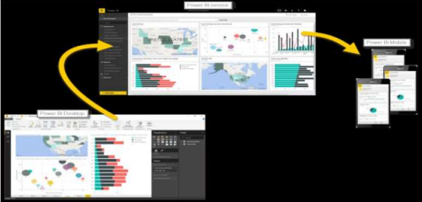

As mentioned earlier, you might spend all your time in the **Power BI service**, viewing visuals and reports that have been created by others. And that's fine. Someone else on your team might spend their time in **Power BI Desktop**, which is fine too. To help you understand the full continuum of Power BI and what it can do, we'll show you all of it. Then you can decide how to use it to your best advantage.

So, let's jump in and step through the experience. Your first order of business is to learn the basic building blocks of Power BI, which will provide a solid basis for turning data into cool reports and visuals.

**Building blocks of Power BI**

Everything you do in Microsoft Power BI can be broken down into a few basic **building blocks**. After you understand these building blocks, you can expand on each of them and begin creating elaborate and complex reports. After all, even seemingly complex things are built from basic building blocks. For example, buildings are created with wood, steel, concrete and glass, and cars are made from metal, fabric, and rubber. Of course, buildings and cars can also be basic or elaborate, depending on how those basic building blocks are arranged.

Let's take a look at these basic building blocks, discuss some simple things that can be built with them, and then get a glimpse into how complex things can also be created.

Here are the basic building blocks in Power BI:

• Visualizations

• Datasets

• Reports

• Dashboards

• Tiles

**Visualizations**

A **visualization** (sometimes also referred to as a **visual**) is a visual representation of data, like a chart, a color-coded map, or other interesting things you can create to represent your data visually. Power BI has all sorts of visualization types, and more are coming all the time. The following image shows a collection of different visualizations that were created in the Power BI service.

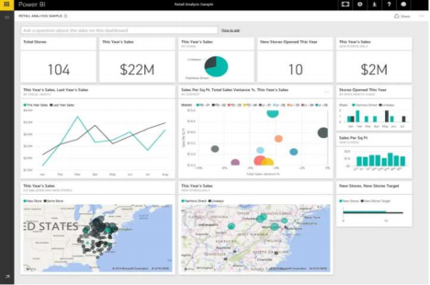

Visualizations can be simple, like a single number that represents something significant, or they can be visually complex, like a gradient-colored map that shows voter sentiment about a certain social issue or concern. The goal of a visual is to present data in a way that provides context and insights, both of which would probably be difficult to discern from a raw table of numbers or text.

**Datasets**

A **dataset** is a collection of data that Power BI uses to create its visualizations.

You can have a simple dataset that's based on a single table from a Microsoft Excel workbook, similar to what's shown in the following image.

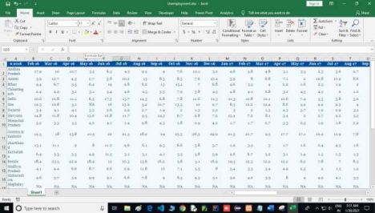

Datasets can also be a combination of many different sources, which you can filter and combine to provide a unique collection of data (a dataset) for use in Power BI.

For example, you can create a dataset from three database fields, one website table, an Excel table, and online results of an email marketing campaign. That unique combination is still considered a single dataset, even though it was pulled together from many different sources.

Filtering data before bringing it into Power BI lets you focus on the data that matters to you. For example, you can filter your contact database so that only customers who received emails from the marketing campaign are included in the dataset. You can then create visuals based on that subset (the filtered collection) of customers who were included in the campaign. Filtering helps you focus your data—and your efforts.

An important and enabling part of Power BI is the multitude of data **connectors** that are included. Whether the data you want is in Excel or a Microsoft SQL Server database, in Azure or Oracle, or in a service like Facebook, Salesforce, or Mail Chimp, Power BI has built-in data connectors that let you easily connect to that data, filter it if necessary, and bring it into your dataset.

After you have a dataset, you can begin creating visualizations that show different portions of it in different ways, and gain insights based on what you see. That's where reports come in.

**Reports**

In Power BI, a **report** is a collection of visualizations that appear together on one or more pages. Just like any other report you might create for a sales presentation or write for a school assignment, a report in Power BI is a collection of items that are related to each other. The following image shows a **report** in Power BI Desktop— in this case, it's the second page in a five-page report. You can also create reports in the Power BI service.

Reports let you create many visualizations, on multiple pages if necessary, and let you arrange those visualizations in whatever way best tells your story.

You might have a report about quarterly sales, product growth in a particular segment, or migration patterns of polar bears. Whatever your subject, reports let you gather and organize your visualizations onto one page (or more).

**Connect to data sources**

Power BI Desktop connects to many types of data sources, including local databases, worksheets, and data on cloud services. Sometimes when you gather data, it's not quite as structured, or clean, as you want it to be. To structure data, you can transform it, meaning that you can split and rename columns, change data types, and create relationships between columns.

In this unit, you will:

• Connect to data.

• Import data into Power BI Desktop.



You can connect Power BI Desktop to many types of data sources, including on-premises databases, Microsoft Excel workbooks, and cloud services. Currently, there are about 60 Power BI-specific connectors to cloud services such as GitHub. You can also connect to generic sources through XML, CSV, text, and ODBC. Power BI will even extract tabular data directly from a website URL.

**Connect to data**

When you start Power BI Desktop, you can choose **Get Data** from the ribbon on the **Home** tab. 

In Power BI Desktop, several types of data sources are available. Select a source to establish a connection. Depending on your selection, you'll be asked to find the source on your computer or network. You might be prompted to sign in to a service to authenticate your request.

**Choose data to import**

After connecting, the first window that you'll see is the **Navigator**. The **Navigator** window displays the tables or entities of your data source, and selecting a table or entity gives you a preview of its contents. You can then import your selected tables or entities immediately by selecting **Load**, or you can select **Transform Data** to transform and clean your data before importing click on Transform data.



After you've selected the tables that you'd like to bring into Power BI Desktop, select the **Load** button. You might want to make changes to those tables before you load them. For example, if you only want a subset of customers or a specific country or region, select the **Edit** button and filter data before loading.

• Click on First Row as a Headers because here we filtering of our data.



• After filter the data then click on apply button.

No matter what type of data you need, you're likely to find a way to import it into Power BI Desktop.

**Create reports**

After your workbook's data has been imported, a dataset is created in Power BI and it will appear under **Datasets**.

Now, you can begin exploring your data by creating reports and dashboards. Select the **Open menu** icon next to the dataset and then select **Explore**. A new blank report canvas appears. On the right-hand side, under **Fields**, are your tables and columns. Select the fields for which you want to create a new visualization on the canvas.

**Create and customize simple visualizations**

In the Visualizations pane, select the type of visualization that you want to create. With this method, the default visual is a blank placeholder that resembles the type of visual that you selected.

**Modify colors in charts and visuals**

Occasionally, you might want to modify the colors that are used in charts or visuals. Power BI gives you control over how colors are displayed. To begin, select a visual and then select the paintbrush icon in the Visualizations pane.



Power BI provides many options for changing the colors or formatting the visual. You can change the color of all bars in a visual by selecting the color picker beside **Default color** and then selecting your color of choice.



You can change the color of each bar (or other element, depending on the type of visual that you selected) by turning the **Show all** slider to **On**. A color selector will then appear for each element.

**Create Pie Chart**

**Pie charts** are generally **used to** show percentage or proportional data and usually the percentage represented by each category is provided next to the corresponding slice of **pie**. **Pie charts** are good for displaying data for around 6 categories or fewer.



**Create Stacked Column Chart**

In a **stacked bar chart**, Axis is represented on Y-axis and value on X-axis and in case of the **stacked column chart**, it's the complete opposite. In the **stacked column chart**, Axis is represented on X-axis and the data is represented on Y-axis.



**Create Donut Chart**

**Donut Chart** (also known as **Doughnut chart**) is a variation on a Pie **chart** except it has a round hole in the center which makes it look like a **donut**, hence the name. This empty space can be used to display additional data.

**Donut charts** are **used** to show the proportions of categorical data, with the size of each piece representing the proportion of each category.



**Create Treemap Chart**

Treemapping is a data visualization technique that is used to display hierarchical data using nested rectangles; the **treemap chart** is created based on this technique of data visualization. This makes the at-a-glance distinguishing between categories and data values easy.



**Create Stacked Area Chart**

A **stacked area chart** is the extension of a basic **area chart** to display the evolution of the value of several groups on the same graphic. The values of each group are displayed on top of each other.



**Create a Table**

A table is a grid that contains related data in a logical series of rows and columns. It may also contain headers and a row for totals. Tables work well with quantitative comparisons where you're looking at many values for a single category. For example, this table displays five different measures for **Category**.

You'll create the table pictured at the beginning of the article to display sales values by item category. 1. From the **Fields** pane, select **Item** > **Category**.

Power BI automatically creates a table that lists all the categories.

1. Select **Sales > Average Unit Price** and **Sales > Last Year Sales**

2. Then select **Sales > This Year Sales** and select all three options: **Value**, **Goal**, and **Status**. 3. In the **Visualizations** pane, locate the **Values** well and select the values until the order of your chart columns matches the first image on this page. Drag the values in the well if needed. Your **Values** well will look like this:



**Create Funnel Chart**

Funnel charts are typically used to show changes over a specific process, such as a sales pipeline or website retention efforts.



**Create Waterfall Chart**

Waterfall charts are typically used to show changes in a specific value over time. Waterfalls only have two bucket options: *Category* and *Y Axis*. Drag a time-based field, such as **Year**, to the Category bucket, and drag the value that you want to track to the Y Axis bucket. Time periods where an increase in value occurred are displayed in red color.



***Challenges***

Large, time-varying datasets pose great challenge for data visualization because of the enormous data volume. Real-time data visualization can enable users to proactively respond to issues that arise. Animation generation approach is used for interactive exploration process of time-varying data. It visualizes temporal events by mimicking the composition of storytelling techniques. Users differ in their ability to use data visualization and make decisions under tight time constraints. It is hard to quantify the merit of a data visualization technique. This is the reason for having a multitude of visualization algorithms and associated software. Most of these software have not taken advantage of the multi-touch interactions and direct manipulation capabilities of the new devices. Big data, structured and unstructured, introduces a unique set of challenges for developing visualizations. This is due to the fact that we must take into account the speed, size, and diversity of the data. A new set of issues related to performance, operability, and degree of discrimination challenge large data visualization and analysis . It is difficult and time-consuming to create a large simulated data set. It is also difficult to decide what visual might be the best to use.

***Conclusion***

Data visualization is the process of representing data in a graphical or pictorial way in a clear and effective manner. It has emerged as a powerful and widely applicable tool for analyzing and interpreting large and complex data. It has become a quick, easy means of conveying concepts in a universal format. It must communicate complex ideas with clarity, accuracy, and efficiency. These benefits have allowed data visualization to be useful in many fields of study.

In all these charts we can see that unemployment rate in India. Highest unemployment rate 29.9% in Jammu & Kashmir in Nov 2016, In Jammu & Kashmir unemployment rate is 21.7% in Jan 2017, In Tripura unemployment rate is 39.1% in Sep 2018, In Tripura unemployment rate is 32.6% in Jan 2019 and in Tripura unemployment rate is 75.8% in April 2020. We can see the chart very highest unemployment rate increases In April 2020 because due to covid-19 all India’s was lockdown and due to lockdown large number of employee’s loss his job. But in the starting some state just as Sikkim has Jan 2016 to Aug2018 no any people 2018 no were jobless but after Aug 2018.but increases unemployed rate in Sikkim, Meghalaya has Jan 2016 to Dec 2017 no any people were jobless but Jan 2018 increases unemployed rate in Meghalaya and Tripura has Jan 2016 to July 2017 no any people were jobless but increase unemployed in Tripura.

***Bibliography***

To make this project we taken help of our teacher Mr. Abhishek Raman, and some following sources:- • www.google.com

• www.cmie.com

• https://unemploymentinindia.cmie.com/kommon/bin/sr.php?kall=wsttimeseries&index_code=0500500000 00&dtype=total